Why Are You Here?


Why Are You HERE?

You run a company. You’re putting sweat, tears, maybe even blood, and certainly money into making it a success.

There are other things you could be doing with your life, yet you’re doing this. For a number of good reasons.

The reasons why you’re running your
company create a very powerful force in
making business decisions. But for most CEOs much of that force is below their conscious radar. It happens intuitively.

It’s very effective to get those reasons and motivations down on paper so you can make better decisions consciously. That’s what we’re going to do in this exercise.

Another way to ask that is …

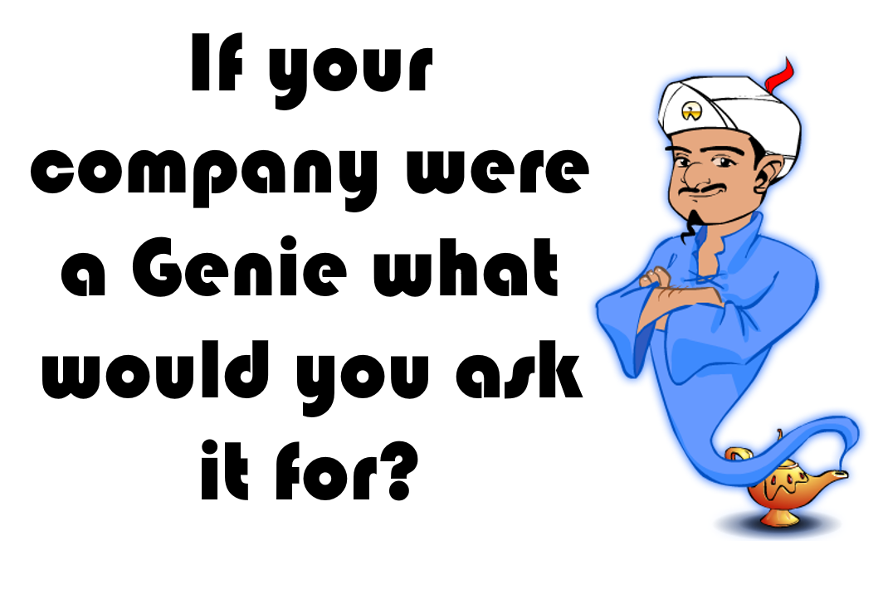

Pick one word to ask your genie for: _______________________________

Since one word isn’t enough, I’ve included some prompts in the rest of this document.
DON’T FILL OUT EVERY PAGE – ONLY THE FEW THAT ARE IMPORTANT TO YOU!

Money, Time, and Work You Enjoy
Those are three things that pretty much everyone wants from their company. Let’s get a bit more specific. First, Money

Money Now
What I’m talking about here is the total amount of money you take out of the company each year. HOW you take it out (salary, profit distribution, loan payback, etc.) is more dictated by tax consequences. I mean the total amount.

How much (in total) have you taken out of the company in the last 12 months? | $ __________________________
Is it more or less than what you need to contribute to your current lifestyle (I said current)? | MORE by how much? __________________  LESS by how much? ___________________
Does what you took out include savings or investments for big expenses you know will be coming, like kid’s education, retirement, etc.? | YES NO

Money Later
Are you counting on selling your company? | YES NO  Not counting on it but would be nice.
How much would you like to walk away with if you sell? | $ __________________________
How much is your company worth today? | I have no idea  I think about $  I’ve gotten a valuation it’s worth about $

Wealth
What % of your wealth is in:
Your business? ________ Your home? _________ Other Investments ________
How happy are you with your wealth at this point in your life? | Very Sort of Not at all

Time
I believe your company should serve your life – not the other way round. If your business is constantly demanding your time, then you’re serving it. You see me, you, Elon Musk, Jeff Bezos (or whoever happens to be the richest individual when you read this) we all have the same 24 hours in a day. So in one sense you can consider that there’s an unlimited amount of money (if you can figure out how to get it) but a limited amount of time.

So the key question is, are you spending most of your time the way you want?

Time at Work
What hours do you work in a typical week? Include work you bring home, weekends, etc. if that’s typical.
Mon | Tues | Wed | Thurs | Fri | Sat | Sun

How does that compare to your ideal schedule?

Have you taken a vacation in the last year? | YES NO
If you get away, are you constantly working on vacation? | YES NO
Does the company do well while you’re gone? | YES NO Sort of
What would be your ideal vacation schedule?

How many? How long?

Work You Enjoy

Are you mostly working IN your business or ON your business? | Mostly IN Mostly ON  Not sure I know the difference

Work
Approximately what % of your work time is spend accomplishing the following outputs:

______ Making product or value customers pay for (or directly managing those who do)

______ Marketing & Sales (or directly managing those who do)

______ Support activities (paying the bills, fixing equipment, dealing with vendors, HR, etc.)

______ Growth (strategy, planning, improving productivity)

Skills & Abilities
What are the things you bring to the company that others aren’t as good at?

What % of your work time involves utilizing those skills?

Challenge & Growth
When you are working, are you doing the things that you most enjoy? YES NO
Does your work challenge you (in a good way)? YES NO
Are your responsibilities at work the best use of your abilities? YES NO
How would you like to change what you do at work?

Where do you want to live?
I lived 1,500 miles away from my company for 25 years. This was before the internet powered work from home - though now good internet service would be high on my priority list. The guy I learned coaching from ran his business from an RV. So I know you can run a company from anywhere.

Here are some things to consider about your location.

Do you want to be mostly in one place or move around a lot?

Which country (or countries) do you want to live in?

Do you want to be near family?

Do you want to be in a city, a suburb, or a rural area (or even on a boat)?

Does the quality of schools matter to you?

Does the cost of living matter? The availability of household servants?

Does access to airports, trains, good roads matter?

I’m going to assume good internet service matters. What other utilities are important? Cable TV? Dependable electricity?

Describe your ideal location:
Would you rather live close to your company or distant from it?

Many Other Things
The following categories are not universal. They matter a lot to some people and not at all to others. But when they matter to you they can be a significant driver of what you want from your company. Ignore the things on this list that don’t matter to you.

To Don’t List
What activities would you ask the genie to do so you’d never have to do them again?

What do you do now that would be better if someone else did it?

Feelings
Not to get too psychological, but most of what we do is motivated by feelings whether conscious or not. Here’s a list of some common emotions. Check off ones you’d like more of or less of at work. Feel free to ignore ones that you’re fine with or add ones I didn’t include.

More Less EXCITEMENT | More Less ANGER
More Less PRIDE | More Less SATISFACTION
More Less OVERWHELM | More Less FRUSTRATION
More Less PEACE | More Less CHALLENGE
More Less SPIRITUALITY | More Less MASTERY
More Less BOREDOM | More Less PURPOSE
More Less AUTONOMY /CONTROL | More Less SENSE OF ADVENTURE
More Less SENSE OF FAILURE | More Less CREATIVITY / DISCOVERY
More Less PURPOSE | More Less INSECURITY
More Less __________________________ | More Less __________________________
More Less __________________________ | More Less __________________________

Mission

Does your company have a mission beyond selling to customers to make a profit? Most companies don’t. But if yours does, describe it here:

Values
Does your company have a written set of values? If so, write it here.
Did you have to go look them up? | YES NO
Do you often feel like business success requires you to compromise your values? | YES NO

Legacy
A legacy is about what you leave behind when you leave your company. It can be passing on the company to family members, creating generational wealth. Or it could be making a lasting contribution to your industry, your customers, or others.

Do you care about leaving a legacy? YES NO If so what would you like it to be?

Financial Security & Risk
How comfortable are you with financial risk? | Very Sort of Not at all
Is your company the main source of your financial security? | YES NO

What’s Next?
Do you have ideas of what you’d like to do in the next phase of your life? For some it’s philanthropy or politics. For others it’s golf or travel. It could even be another business.

Do you have ideas of what’s next for you? YES NO

If you do, how can your company lay the groundwork for that?

Community & People
Business brings you around many groups of people: your customers, your employees, your vendors, and suppliers - just to mention a few. A business can also give you a standing in your community, putting you in a position to help others or to notice trends.
What groups of people would you love to be more involved with?

Less involved with?

Freedom
People often say running a company gives them freedom – say, from a terrible boss or corporate constraints. But you have to serve customers (and to some degree employees) as an entrepreneur. It helps to know what freedom means to you specifically.
What do you want to be free FROM or free to DO that your business will allow?

Status & Identity
It's been said that ego is a part of every entrepreneur's make up. I've found this mostly true in a very positive way. The best companies have owners who get a real sense of pride from being successful at their companies.

On the other hand, I’ve seen people get so caught up in their identity and status, that it actually kept them from doing the things that would bring them success. If your self-worth depends only on how well you succeed, it can actually be a recipe for failure. It can cause your success to feel hollow.

Close your eyes. Imagine your business is more successful than you ever dreamed. Write a sentence or two describing what's different about your life because of that.

How would you like to change how your identity and business are connected?

Working Style
How do you like to work? Do you enjoy a consistent routine or do you prefer unpredictability? Do you like solving problems or performing repetitive tasks? Do you prefer creativity or imitation? Do you enjoy planning and then methodically carrying out your plan, or are you happier reacting on the fly to whatever comes your way? Think about the style of work you prefer.

What would you like to change about your working style?

What support would you need from your team to make those changes.?

Travel

How much do you want to travel for work? | More than I do now  Less than I travel now  Current travel is great
Where would you like to travel for work?
What are the best reasons for you to travel for work? Sales? Research? Meet with Vendors?

Family & Spouse
Even if your Significant Other isn’t officially part of the company it affects them and your family.

What changes would you like to see in the company’s effect on your spouse or life partner?

How about the effect on the rest of your family?

Partners
A partner in this context is someone who owns part of the company with you.
If you have a partner or partners in your business, how satisfied are you with those relationships? | VERY Not So Much It’s TERRIBLE
If you don’t have a partner do you want one? | No I’m happy owning it all.  I’d like a silent partner (one who provides money but doesn’t work in the company)  I’d like a working partner with these skills:

Fame
Fame comes in many flavors: industry-wide, local, national, global.
And it takes many forms: thought leadership, writing a book, TV, internet followers.

What aspect of fame would you like your business to provide?

What would indicate you’ve achieved the kind of fame you desire?

Fun
Do you enjoy what you spend most of your time doing at work?
What do you most enjoy doing?
What do you wish you could do more of?
What things do you enjoy away from work that work is keeping you from doing?

What Else?
What have I not covered that you’d like from your company?

Progress Chart
Go back through what you’ve written. Make any changes that occur to you. Now list the few most important things that you want FROM your company. No more than five. Even just one is fine.

Put that in the left most column. In the next column, indicate how you’ll measure success. Then put your goal and the current status of that category.
Here’s an EXAMPLE:
Category | As Measured By | Goal | Current Status
Wealth | $ Invested outside the company | $10 Million | $500,000

Now You
Category | As Measured By | Goal | Current Status

You can make copies of this chart to measure your progress. Also, when you’re making strategic decisions, use this chart to guide your thoughts about which decision will help the most to get you what you want.

Congratulations



You have just completed an exercise of working ON your company (not IN it). By pulling back from the day to day and taking a more long term view of your business you have laid the foundation to grow it into the kind of firm that can provide you with what you want.

As your coach, I’ll help you with that.

Anything else I should know? Jot it down here:

